Sonoita-Elgin Fire District
Public Safety Personnel Retirement System
Pension Funding Policy

The intent of this policy is to clearly communicate the Fire Board’s pension funding objectives and its commitment to our employees and the sound financial management of the Sonoita-Elgin Fire District and to comply with statutory requirements of Laws 2018, Chapter 112.

Several terms are used throughout this policy:

Unfunded Actuarial Accrued Liability (UAAL) – Is the difference between trust assets and the estimated future cost of pensions earned by employees. This UAAL results from actual results (interest earnings, member mortality, disability rates, etc.) being different from the assumptions used in previous actuarial valuations.

Annual Required Contribution (ARC) – Is the annual amount required to pay into the pension funds, as determined through annual actuarial valuations. It is comprised of two primary components: normal pension cost – which is the estimated cost of pension benefits earned by employees in the current year; and, amortization of UAAL – which is the cost needed to cover the unfunded portion of pensions earned by employees in previous years. The UAAL is collected over a period of time referred to as the amortization period. The ARC is a percentage of the current payroll.

Funded Ratio – Is a ratio of fund assets to actuarial accrued liability. The higher the ratio the better funded the pension is with 100% being fully funded.

Intergenerational equity – Ensures that no generation is burdened by substantially more or less pension costs than past or future generations.

The Sonoita-Elgin Fire District fire employees who are regularly assigned hazardous duty participate in the Public Safety Personnel Retirement System (PSPRS).

Public Safety Personnel Retirement System (PSPRS)

PSPRS is administered as an agent multiple-employer pension plan. An agent multiple-employer plan has two main functions: 1) to comingle assets of all plans under its administration, thus achieving economy of scale for more cost efficient investments, and invest those assets for the benefit of all members under its administration and 2) serve as the statewide uniform administrator for the distribution of benefits.

Under an agent multiple-employer plan each agency participating in the plan has an individual trust fund reflecting that agencies’ assets and liabilities. Under this plan all contributions are deposited to and distributions are made from that fund’s assets, each fund has its own funded ratio and contribution rate, and each fund has a unique annual actuarial valuation. The Sonoita-Elgin Fire District has one trust fund for fire employees.

The Fire Board formally accepts the assets, liabilities, and current funding ratio of the Sonoita-Elgin Fire District PSPRS trust funds from the June 30, 2025 actuarial valuation, which are detailed below.

Liabilities and Funded Ratios – Tiers 1 & 2

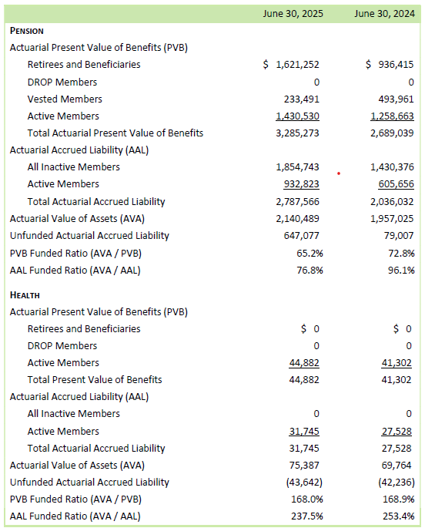

Liabilities and Funded Ratios – Tier 3

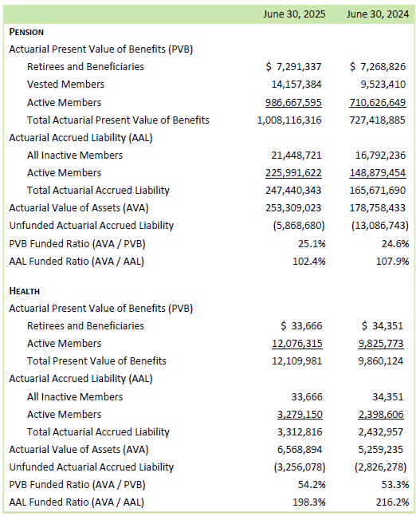

PSPRS Funding Goal

Pensions that are less than fully funded place the cost of service provided in earlier periods (amortization of UAAL) on the current taxpayers. Fully funded pension plans are the best way to achieve taxpayer and member intergenerational equity. Most funds in PSPRS are significantly underfunded and falling well short of the goal of intergenerational equity.

Proposition 207
In 2020, AZ voters approved Prop 207 the “Smart and Safe Arizona Act.” As part of this initiative a “Smart and Safe, Arizona Fund” was established to receive revenue from a 16% excise tax and licensing and registration fees. As a fire department with individuals enrolled in PSPRS, the Fire District is eligible to receive this revenue based on the number of PSPRS individuals and taxes and fees collected. The Arizona State Treasurer will distribute these funds biannually, June 30 and December 31.

The Fire Board’s PSPRS funding ratio goal is 100% (fully funded) by June 30, 2036.

Fire Board established this goal for the following reasons:
- The PSPRS trust funds represent only the Sonoita-Elgin Fire District liability
- The fluctuating cost of an UAAL causes strain on the Sonoita-Elgin Fire District budget, affecting our ability to provide services
- A fully funded pension is the best way to achieve taxpayer and member intergenerational equity

Fire Board has taken the following actions to achieve this goal:
- Maintain ARC payment from operating revenues – Fire Board is committed to maintaining the full ARC payment (normal cost and UAAL amortization) from operating funds.
- Additional payments above ARC.
  - Annually evaluate prior years budget compared to actual expenditures may permit excess payments.
  - It is the policy of the Sonoita-Elgin Fire District Board to use the money received from the Smart and Safe Arizona Fund to pay the districts PSPRS related liabilities.

Based on these actions the Fire Board plans to achieve its goal of 100% funding by June 30, 2036, in accordance with the amortization timeline set forth by the PSPRS June 30, 2025 Actuarial Valuation.

