Minutes to the Board of Directors Meeting
March 23, 2026
Chair of the board Chris Johnson calls the meeting to order at 9:00 a.m.
- Roll call and confirmation of Quorum.
Chris Johnson, Ruth Ann LeFebvre, Robert Garber, Eddie McArthur and Kat Crockett are present and The Board has a quorum.
- Pledge of Allegiance to the Flag.
- Call to the public.
- Members of the public are invited to address the Board and/or submit written comments for inclusion in the minutes. Members of the Board shall not discuss or take legal action on matters raised during an open call to the public, unless the matters are properly noticed on the agenda for discussion and legal action.
- No members from the public.
- Approval of the Minutes from past meetings-
- Minutes from the February 2026 Board Meeting presented.

Ruth Ann LeFebvre moves to approve the minutes from the February 2026 Board meeting, Eddie McArthur seconds the motion and it’s approved unanimously.

5. Reports from the Fire Chief or his designee may include the following topics:
2024-2026 Strategic Plan Implementation:
- 2024-2026 Strategic Plan
- We are extending the end time of the plan to December 2027. We will create an addendum to the plan to reflect this extension. An update on progress will be provided at the March meeting
- Administration/Budget:
- SCC Treasurer Update- SCC Supervisors considered a possible resolution with Rio Rico Fire & Medical at their 03-18 meeting. The County’s suit against the state of Arizona was dismissed.

• Work on the FY26-27 continues. We need to set a date for public workshop.
- Special Department Logo Planned use will be April 1, 2026 to June 30, 2027.

- Santa Cruz County CWPP Update:
- The Santa Cruz County Wildfire Protection Plan draft has been finalized and will be on the April agenda for adoption by the SEFD Board.
- Office of Emergency Management funding is at risk for next fiscal year.
- Pima County Updates:
- The Pima County Wildfire Protection Plan update should be available for comment by March.
- PSPRS Local Board:
• The Local Board met in November and will next meet in the spring of 2026.
- Operations:
- Staffing: FF Herrera, FF Sanchez and FF Olkiewicz have all started on shift
- FF Reynosa will be sworn in later today
- Operations: M832 needs significant work done and is being held in reserve for the moment.
- District Growth/Development:
- Planned subdivisions: Papago Springs, AZ 82(removed commercial element).
- Proposed Dude Ranches: Babacomari (no updates). Double R Ranch (new and in County approval process).
- Proposed Wineries • Brigand (moving forward, SEFD has approved plans)
- Proposed Vet Clinic • 3129 AZ 83 in the initial plan review stage
- Dollar General Remodel (SEFD has approved plans
- Neighboring Agency News & Developments: Town of Patagonia Update.
- Firewise and Fuels Mitigation News & Updates: (SCC CWPP and PC CWPP)
- Total incidents for the month of February ended at 55 and here is the breakdown: FIRE-1, RESCUE & EMS-31, HAZARDOUS CONDITION-0, RESCUE-0, PUBLIC SERVICE-8, NO EMERGENCY- 15, AND ASSISTING LAW ENFORCEMENT-0. Incident count by Zone: Zone 1 had 27, Zone 2 had 10, Zone 3 had 4, Zone 4 had 2, and Zone 5 had 12 for a total of 55. Under incident count by day, the busiest days of the week were Thursday & Saturday, and Friday was trending the next highest and most calls running during the day. There were 41 incidents during the day and 14 incidents during the night hours.
- Legislative Update:
• Senate: SB1130- Property Tax Exemption for Certain First Responder Survivors, amends ARS 42- 11111 to expand property tax exemptions to include widows and widowers of first responders with LODD or LODD caused by injuries (AFDA support) • SB1216- Traumatic Event Counseling, removes repeal provisions (AFDA support) • SB1504- PSPRS Service Requirement, provides for Tier 3 to fully retire at 25 years of service
• Federal: HR1- Reduces Medicaid spending by approx. 900 billion over six years. Potential to increase under or non-paid transports • Federal Wildland Fire Agency Reform- Uncertainty over timeline and final composition of the new US Wildland Fire Service (currently excludes USFS) Legislative Session convened Monday, January 12, 2026

- Presentation and Approval of Monthly Financial Reconciliation and Reports pursuant to ARS Sec. 48-807 including:
• reconciled balance sheet accounts;
• month-end statements;
• month-end balances at all institutions and county accounts;
• revenues and expenditures; and
• cash flow projection report.

Ben Archer Clowes from James Vincent Group presents the January Financials to the Board. Cash is up to $194,000, which is fantastic to see. Ben explains why he shows a year over year comparison for tax revenue and how the cash balance has varied, due to when that comes in during the year. We are slightly behind where we would expect to be from a tax revenue but it all depends on when the tax revenue comes in. Revenue is $44,000 over where we thought we would be this time of the year. We are over on some expense categories including the vehicle maintenance that is $42,000 over budget and building and grounds which is $28,000 over budget. Chief responds to Robert Garbers comments about vehicle maintenance, and it will continue to be a concern and a strong conversation to re-evaluate our fleet size and the age of the fleet during the Strategic Planning process and the budget process yearly.

Robert Garber moves to approve the February 2026 financials, Eddie McArthur seconds the motion and it passes unanimously.

7. (A) The Governing Board may vote to convene an executive [closed] session pursuant to A.R.S. 38- 431.03(A)(3) and (4) for discussion or consultation for legal advice with the Board’s attorney and/or to consider its position regarding possible litigation options and/or to instruct its attorney regarding settlement discussions conducted to avoid or resolve litigation and related matters surrounding the Gutfahr / Santa Cruz County Treasurer Theft matters.

Robert Garber moves for the Board to enter into Executive Session at the advice of the Board attorney Thomas Benavidas, Eddie McArthur seconds the motion and it’s approved by four with one opposition from Ruth Ann LeFebvre.

- The Board enters into executive session at 9:15a.m., everyone except Chief Meredith exits the room.
Robert Garber moves for the Board to exit Executive Session and return to the regular Board meeting, Eddie McArthur seconds the motion and it’s approved by

- The Board exits executive session at 9:42a.m.

7. (B) Following the executive session, the Board might take action to approve the direction (if any) given to the Governing Board’s attorney during the executive session, above.

- (C) Following the executive session, the Board might take action to authorize the Board’s attorney(s) to send a settlement offer to Santa Cruz County and the State of Arizona in connection with the Gutfahr / Santa Cruz County Treasurer Theft matters.

Eddie McArthur moves to authorize attorney Thomas Benavidas to negotiate a settlement offer with Santa Cruz County and the State of Arizona in connection with the Gutfahr/Santa Cruz County Treasurer Theft matters, Robert Garber seconds the motion and it passes unanimously.

8. United Firefighters of Sonoita Update to Board.
- Tim Hart, FF/PM is the president of the union at SEFD and will present information and updates to the Board on a monthly basis. Tim expresses his gratitude for the support of the Board and Chief, currently we have 11 members. The largest threat to life as a firefighter is occupational cancer. As a union we have two attainable future goals: cancer prevention and having a member who lives in the district.

- Information item- update on Santa Cruz County Office of Emergency Management funding
- Covered during the Chief update report.
10. Information item- update on development of property in Elgin
- Chief addresses the Board, that we are actively working to operationalize the property in Elgin, for a fire resources facility and training space. He has had a brief conversation with the CEO of Legacy Foundation of Arizona, and they confirmed that they will be discussing our grant request with their Board in the April meeting. We are waiting for a formal invitation to discuss the project.

11. Special Presentation- awarding of Distinguished Action Pins for Code Save.
Chief awards Jose Beltran (furthest on the left), Estevan Reynosa, William Sanchez, Michael McGonigle and Tim Hart distinguished action pins and certificates for their actions that saved a life of a community member. Folks from Banner Hospital attended to recognize the crew on call that day and Jake Merry the Base Hospital Coordinator spoke and presented the firefighters with challenge coins.

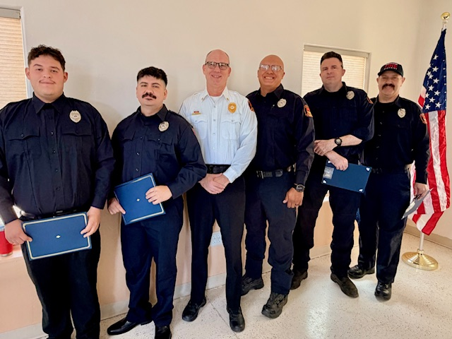

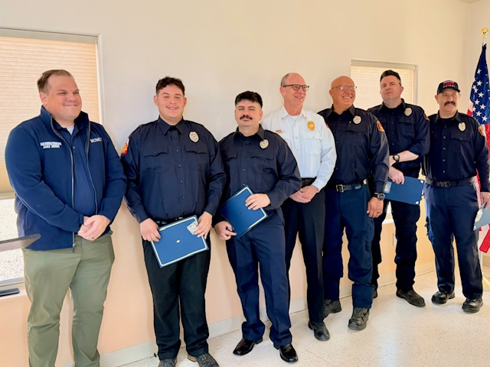

12. Special Presentation- swearing in of Firefighter Reynosa.
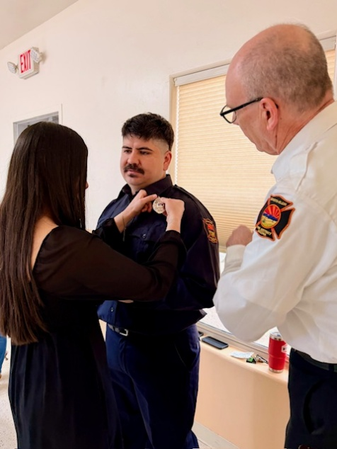
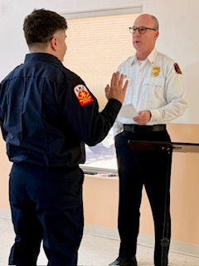

13. Consideration of possible future agenda items.
- Elgin property update.
- Further research and conversation about the industry cancer risk for firefighters.
- Sketched out Budget Presentation.

Robert Garber moves to adjourn the meeting; Kat Crockett seconds the motion and the motion is carried without opposition.

Chris Johnson adjourns the meeting at 10:30 a.m.
A digital copy of this meeting is available to the public at the Sonoita-Elgin Fire District, located at 3137 AZ Highway 83 Sonoita, AZ 85637

NOTICE: The Sonoita-Elgin Fire District Board of Directors may go into executive session for the purpose of obtaining legal advice from the fire district’s attorney(s) on any of the above agenda items pursuant to A.R.S. 38-431.03(A)(3)
Minutes approved by________________________, Board Clerk, on ___________
Ruth Ann LeFebvre Date

