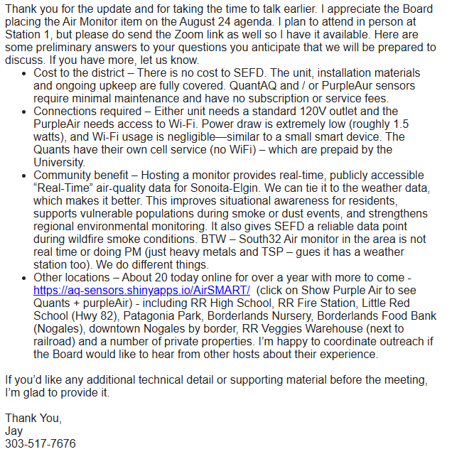
PURPLEAIR AIR MONITOR INFORMATION

